Assignment 1 - EC2 Auto Start/Stop
Created a EC2 instance
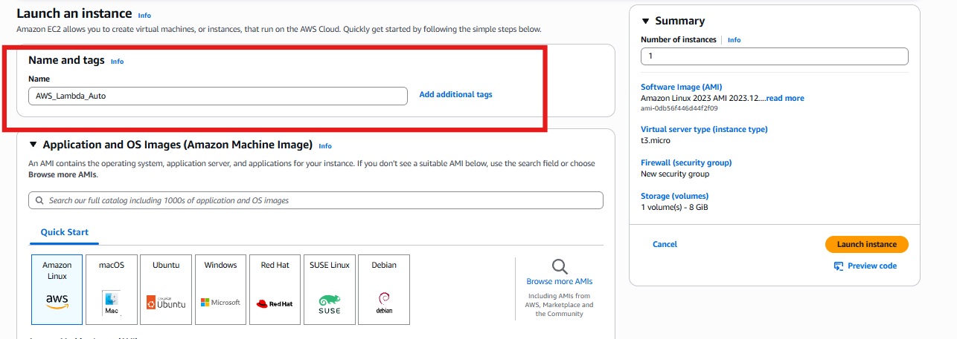
Go to the EC2 instances and crea a Tag for the “Auto-Stop”
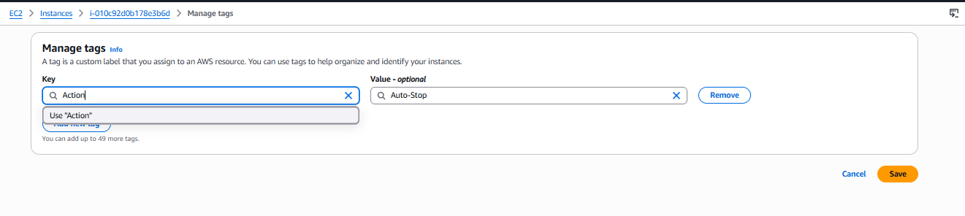
Created nother instance and put name as a Lambda Start
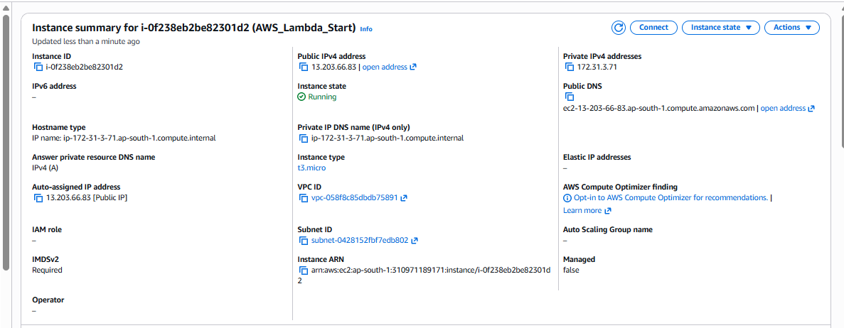
Creating the IAM role for the instance Lambda
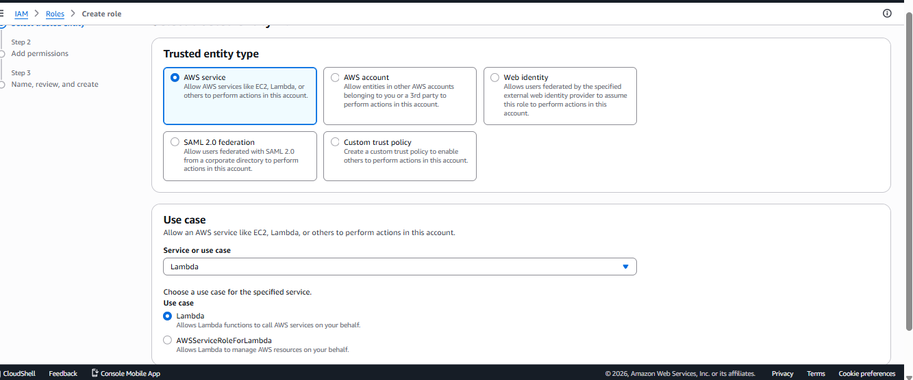
Given the Permission for the Lambda and EC2 full access,
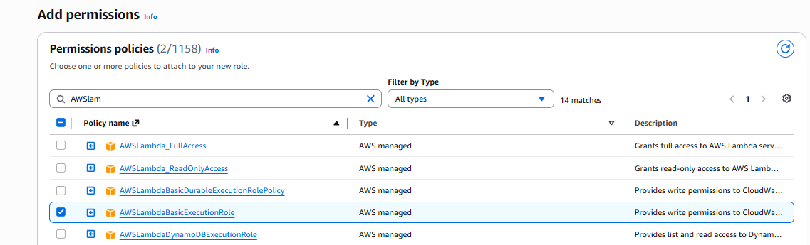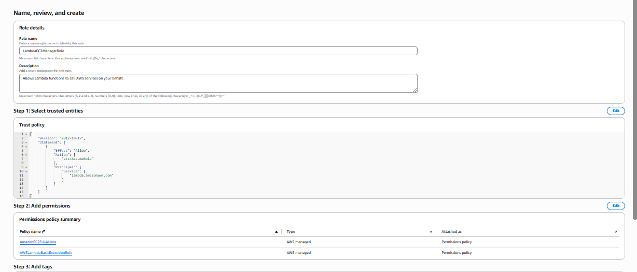

AWS Lambda :
Open the Lambda console ,and created the function

Created the function “Use the Auther from Scratch “
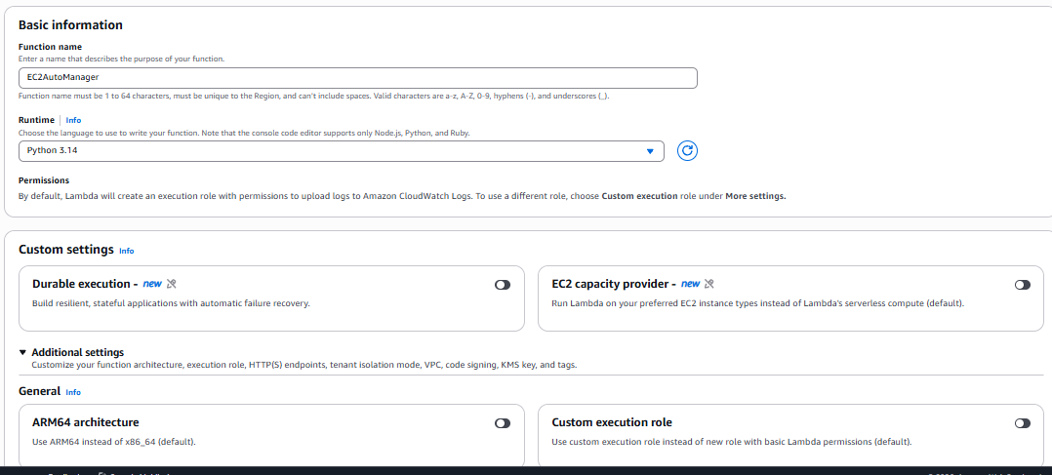
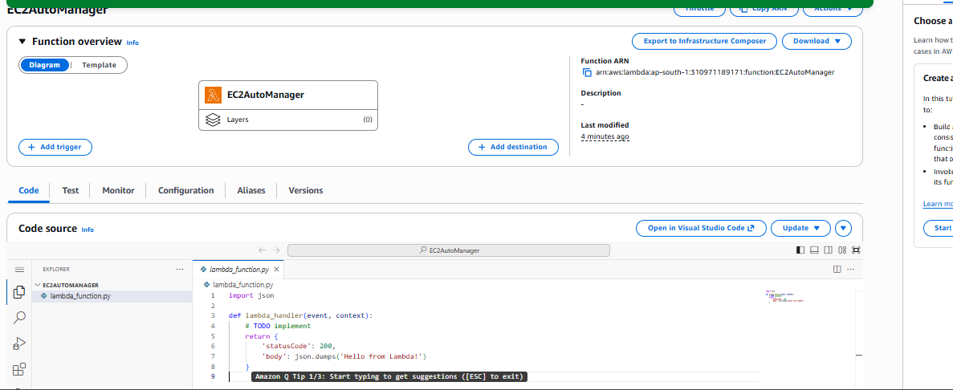
Remove the default code and add the code and deploy
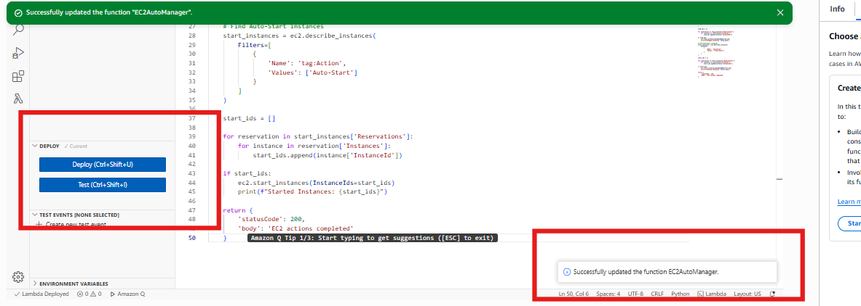

Created the “Test “ and it is successful
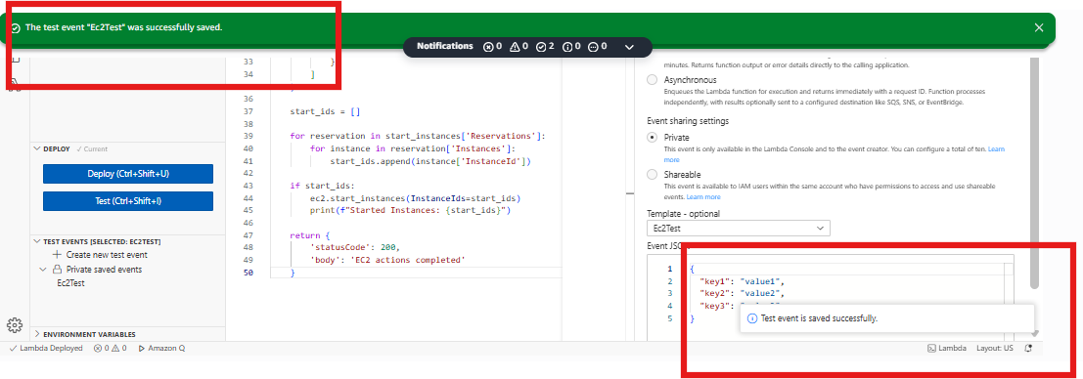
Run the test and the result is successful
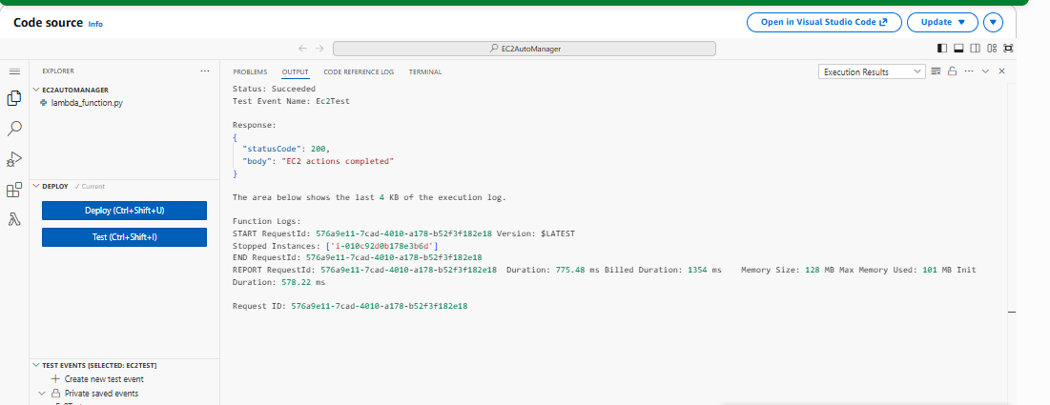

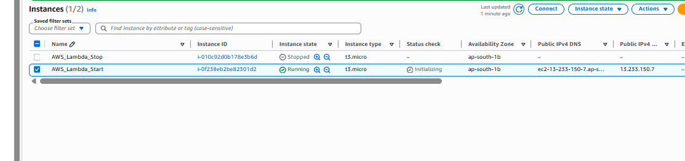

Assignment 5 - Auto Tagging EC2
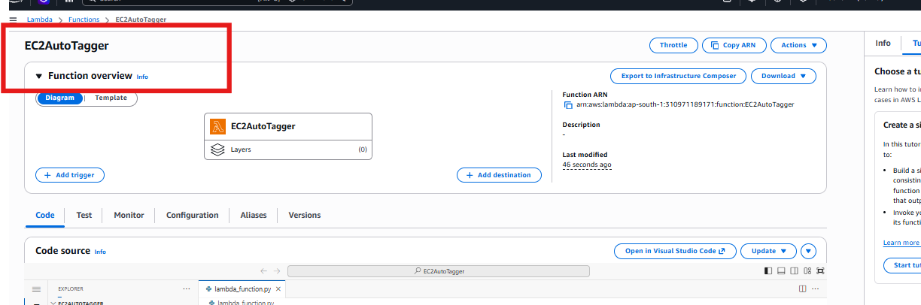
The code was deployed sucessfuly
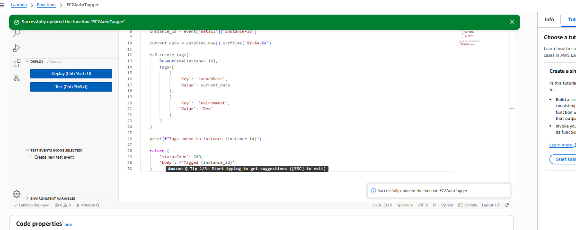

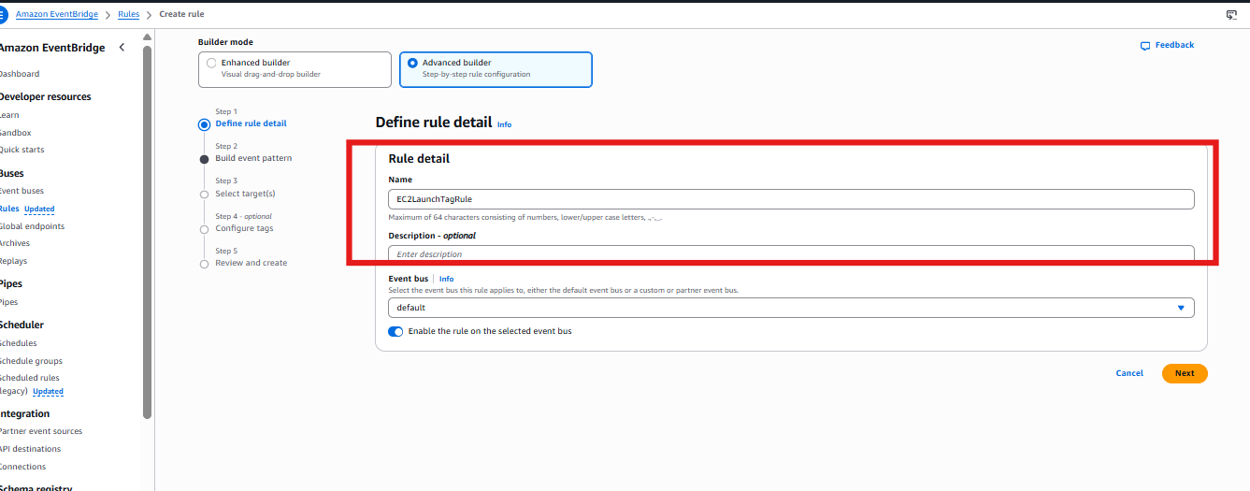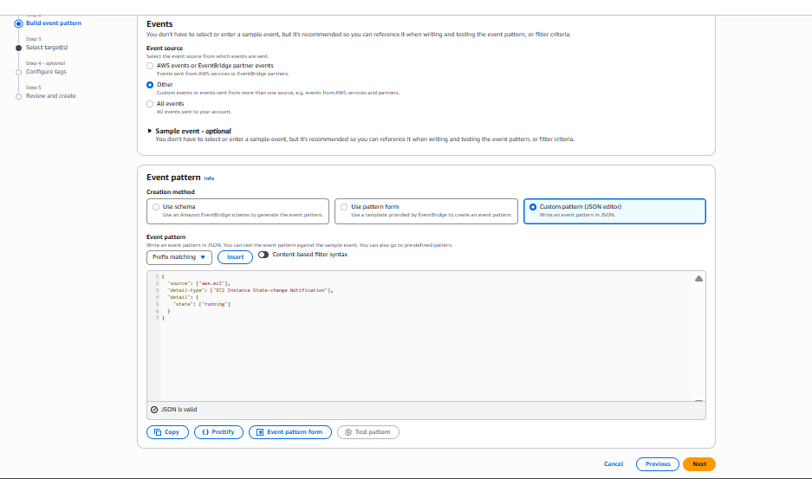

Created the Tagger ,
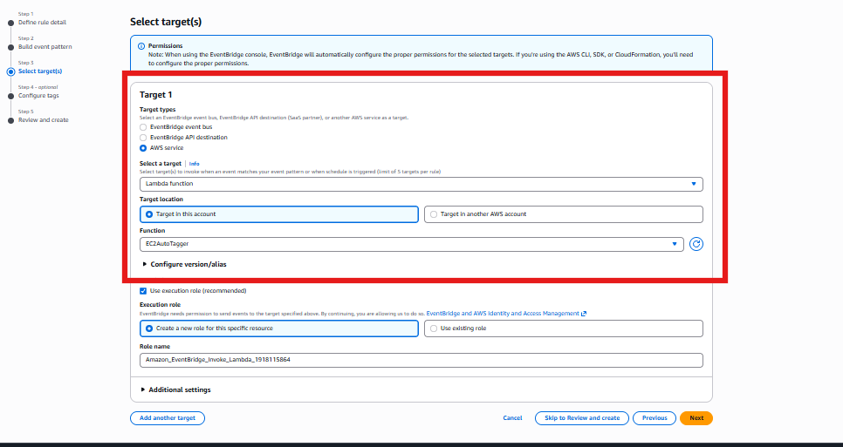
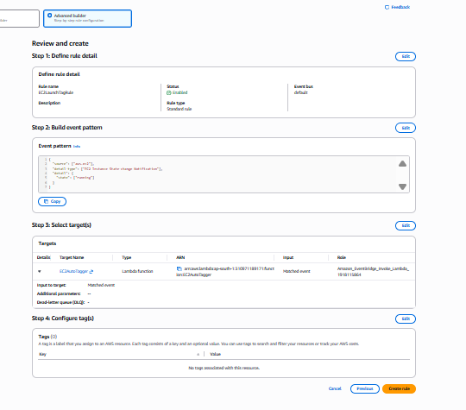
Created the Event pattern Rule for the Ec2 Auto tagging
Created the New Instances
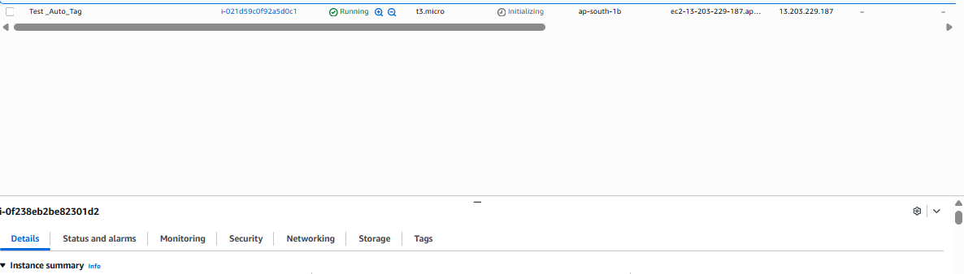

Check the Tags for thr New instnaces
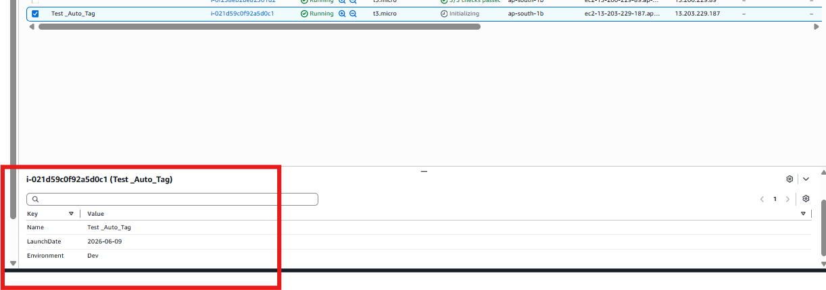

Assignment 7 - DynamoDB Alerting

Crea a SNS (Simple Notification Services)
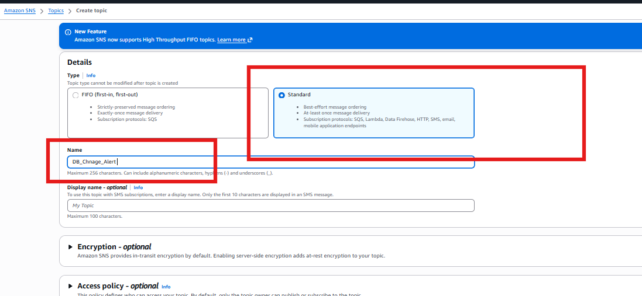
We need to create the subscriptions to get the notifications
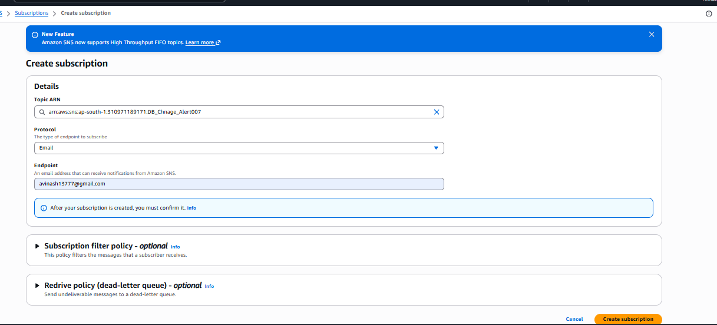
We need to get confirm the email subscription
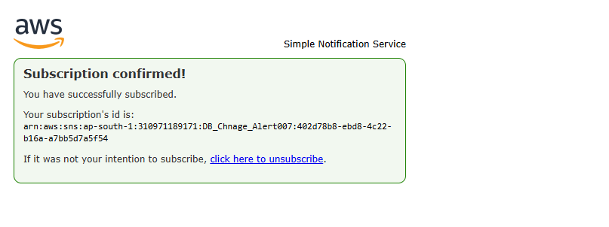

Open the DynamoDB Table to creat a DB
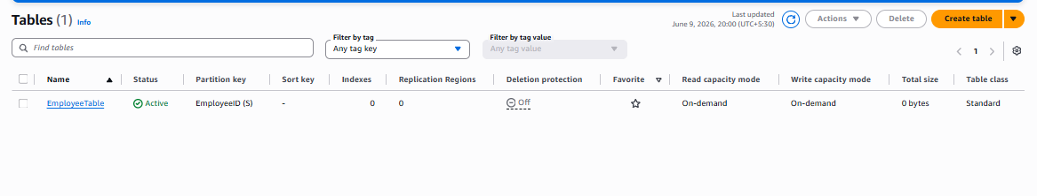
Created the sample employee table
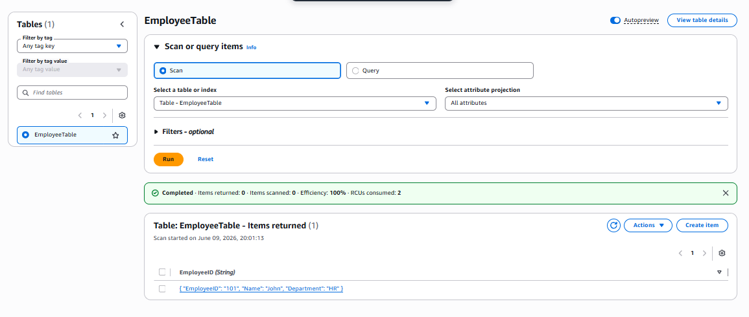
Enable the DynoDB stream
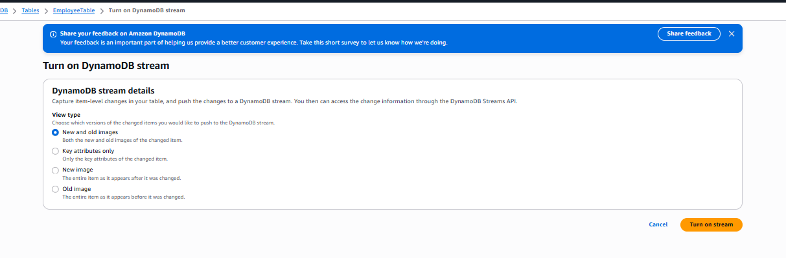
Created the IAM role for SNS and DyanmoDB
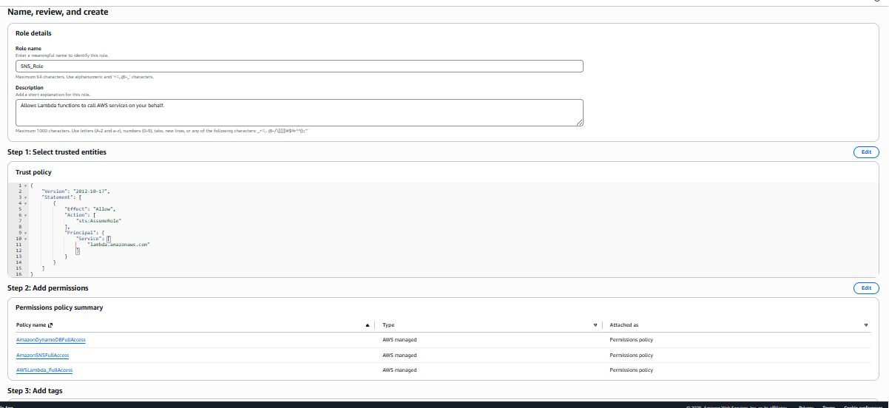
Created the Lamda function
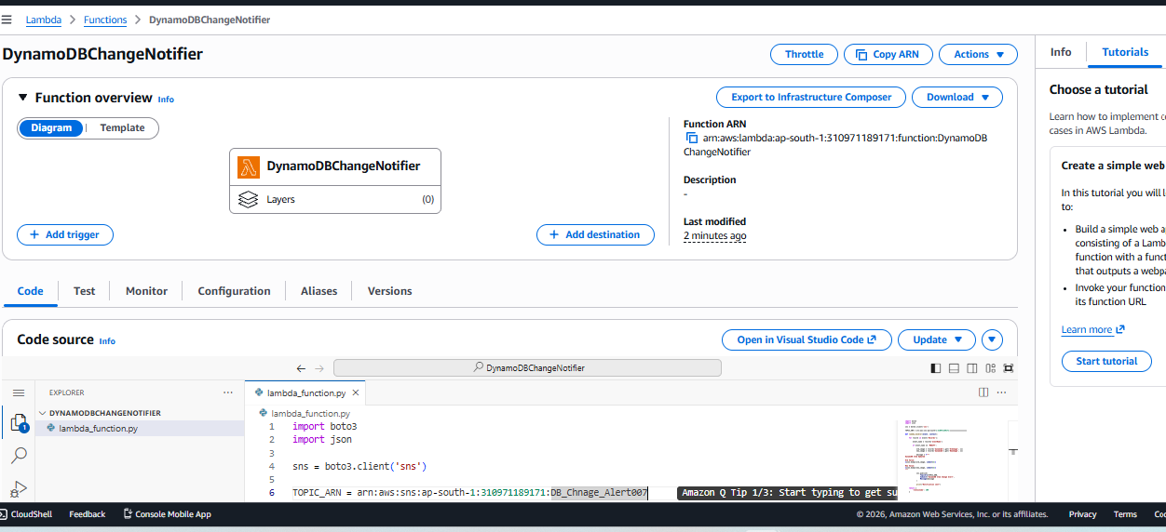

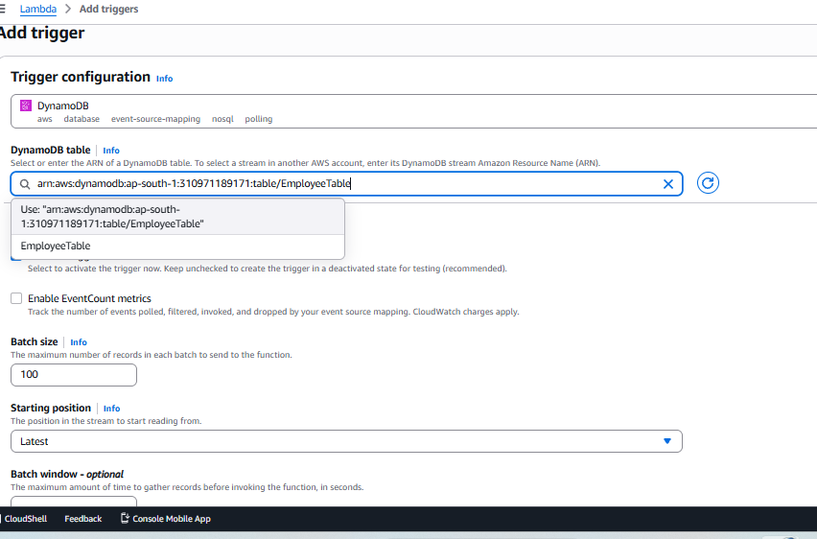
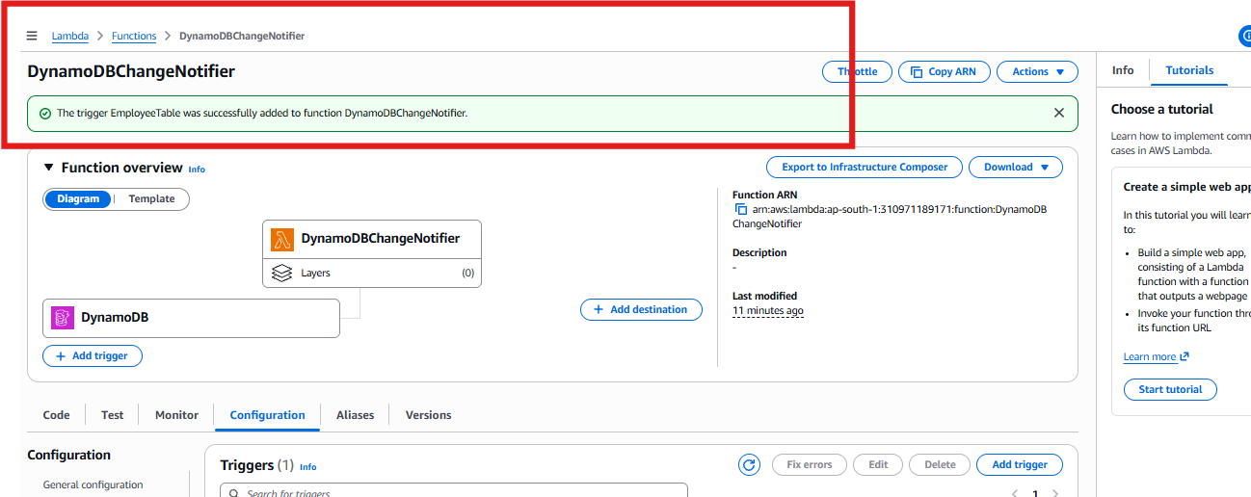

After adding the I We did the test , Go to the Dynamo DB and
Edit the Table steam,
We will get the notification
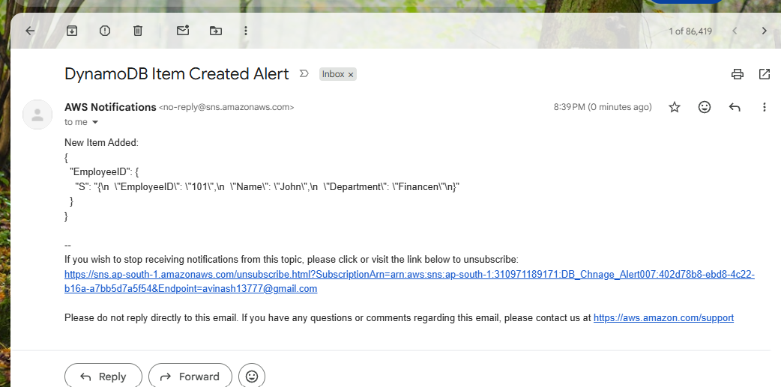

Assignment 13 - S3 Security Audit
We need to create the S3 bucket
Created thwo buckets 1, Public and Private

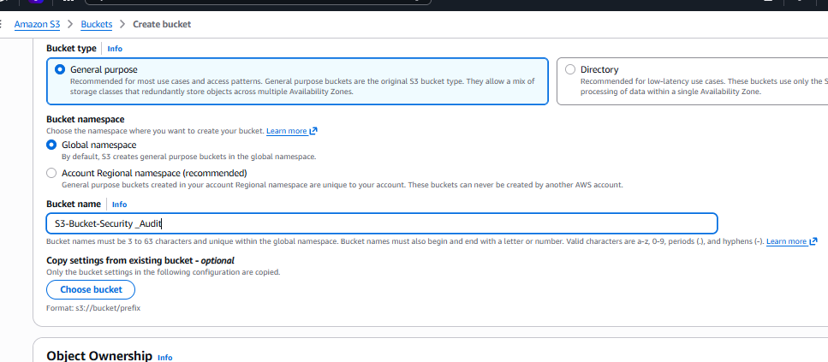
Block the all the Public access un check

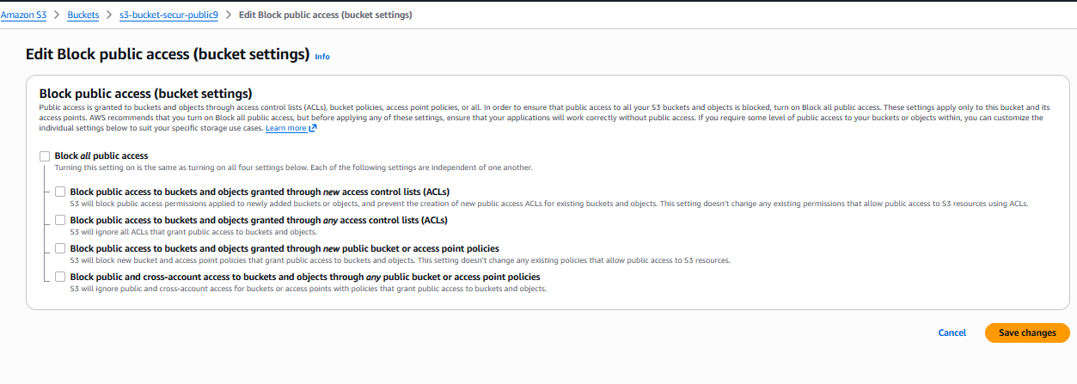
After add the bucket permission
Create the SNS notification for the S3
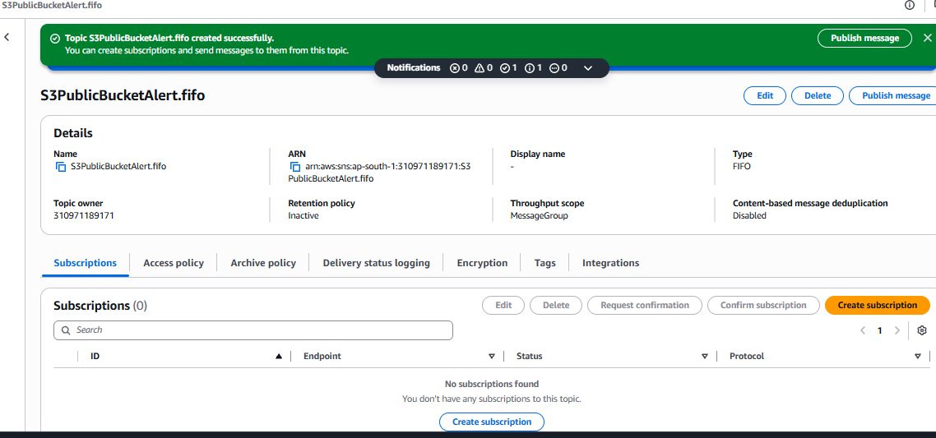

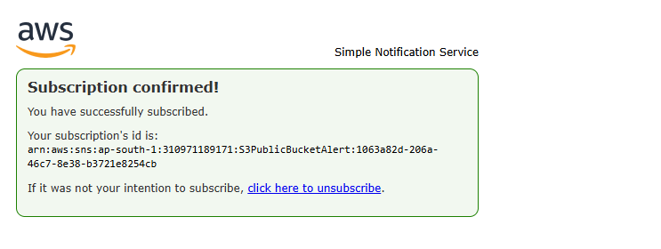

Now we need to create the IA m role for the S3
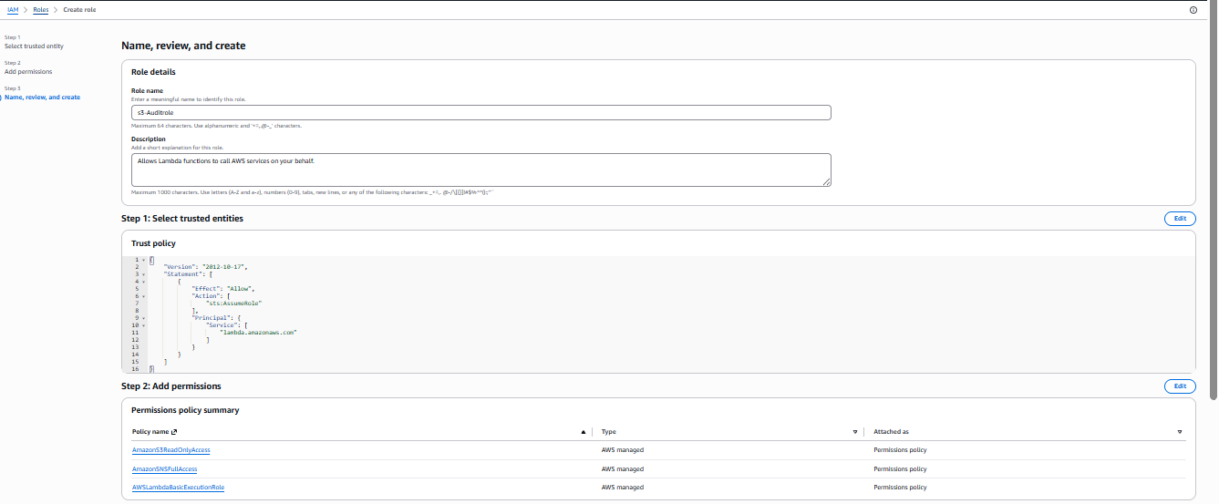

Creat a Lambda function
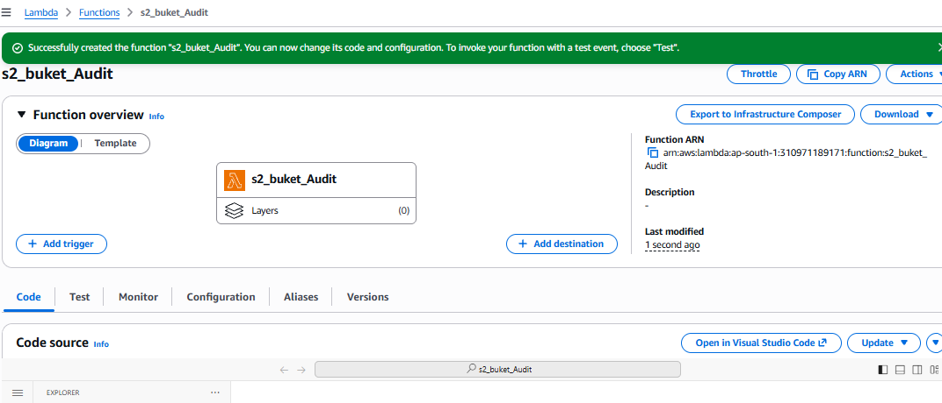

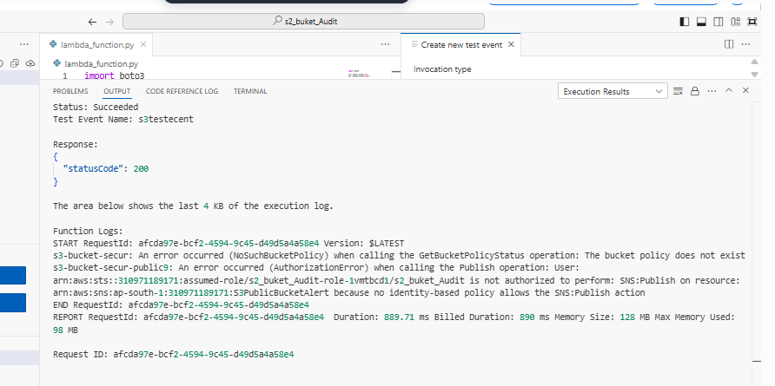
The Email is received
